DevOps

Class 1: 07/22/2025

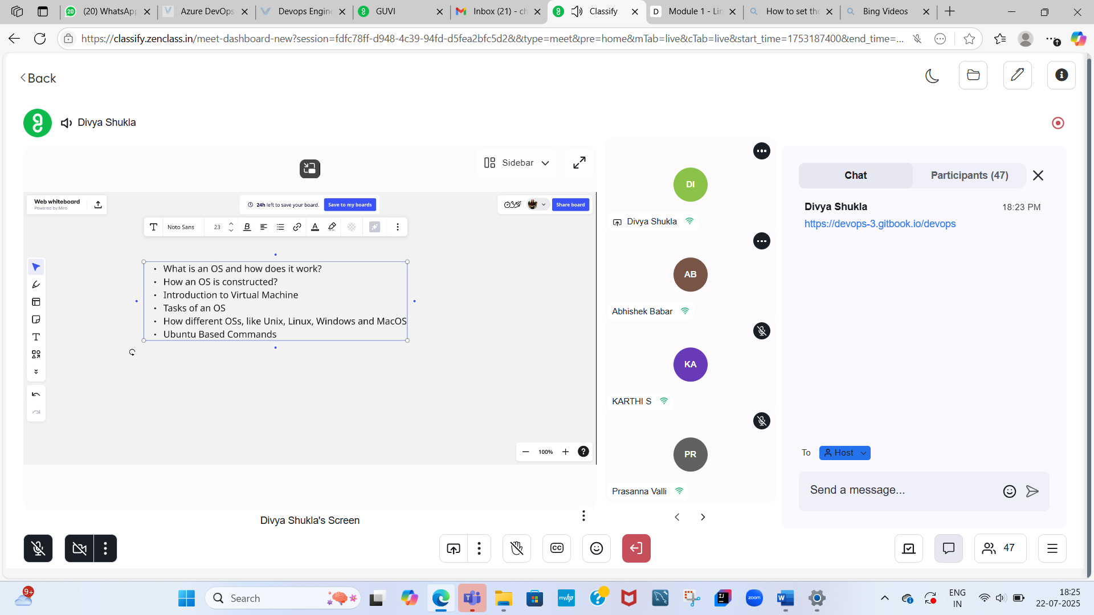

<https://classifyprod.s3.ap-south-1.amazonaws.com/documentShared/fdfc78ff-d948-4c39-94fd-d5fea2bfc5d2/ebook-Linux_Linux_Command_Line,_Cover_all_essential_Linux_commands_A_complete.pdf>

* Linux Commands Pdf.

**Basic Linux Commands:**

1. pwd – Present Working Directory
2. mkdir test – To create a ‘test’ directory (To create a test folder inside Ubuntu)
3. Ls – To check anything inside the mentioned directory
4. Cd – Current directory (Ex: cd test – To get into test folder)
5. Touch file.txt - To create not a Folder but a file (here txt is the extension)
6. As it is CLI based OS we have to know CLI based text editor – Either VIM or Nano.

Now we will be using VIM editor

1. Vi file.txt (Ex: vi file name.txt )
2. Then we will enter to Vim editor screen
3. Press I – We will go to INSERT mode on vim editor
4. Type the command Ex: This is my 1st VI note – “Hello World”
5. Then press esc key
6. :wq – To exit from the vim editor. (W stands for write this command and quit)
7. Cat file.txt – To read the content of the file (cat file name)

Access for different users on Linux server –

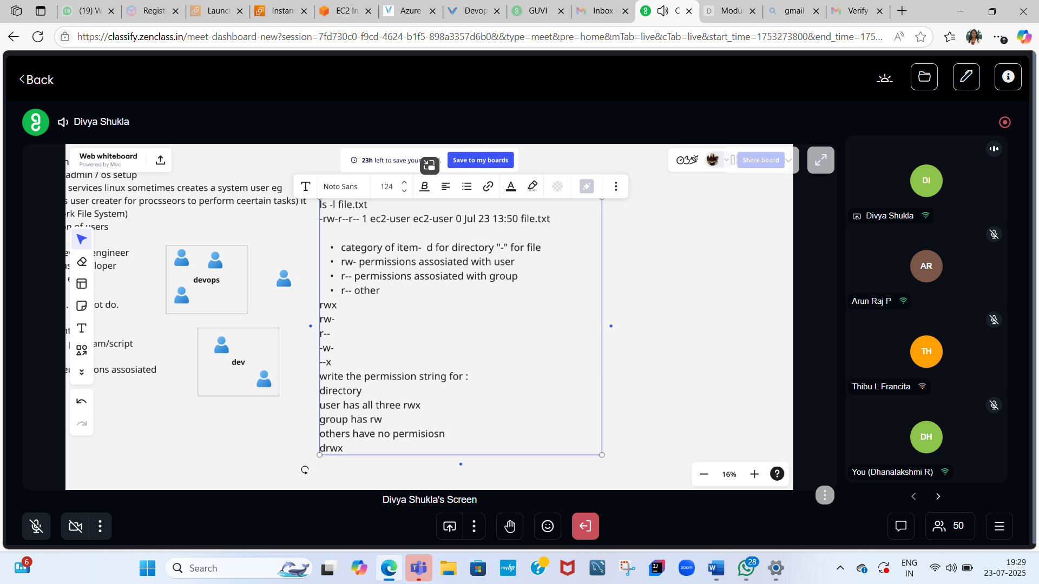

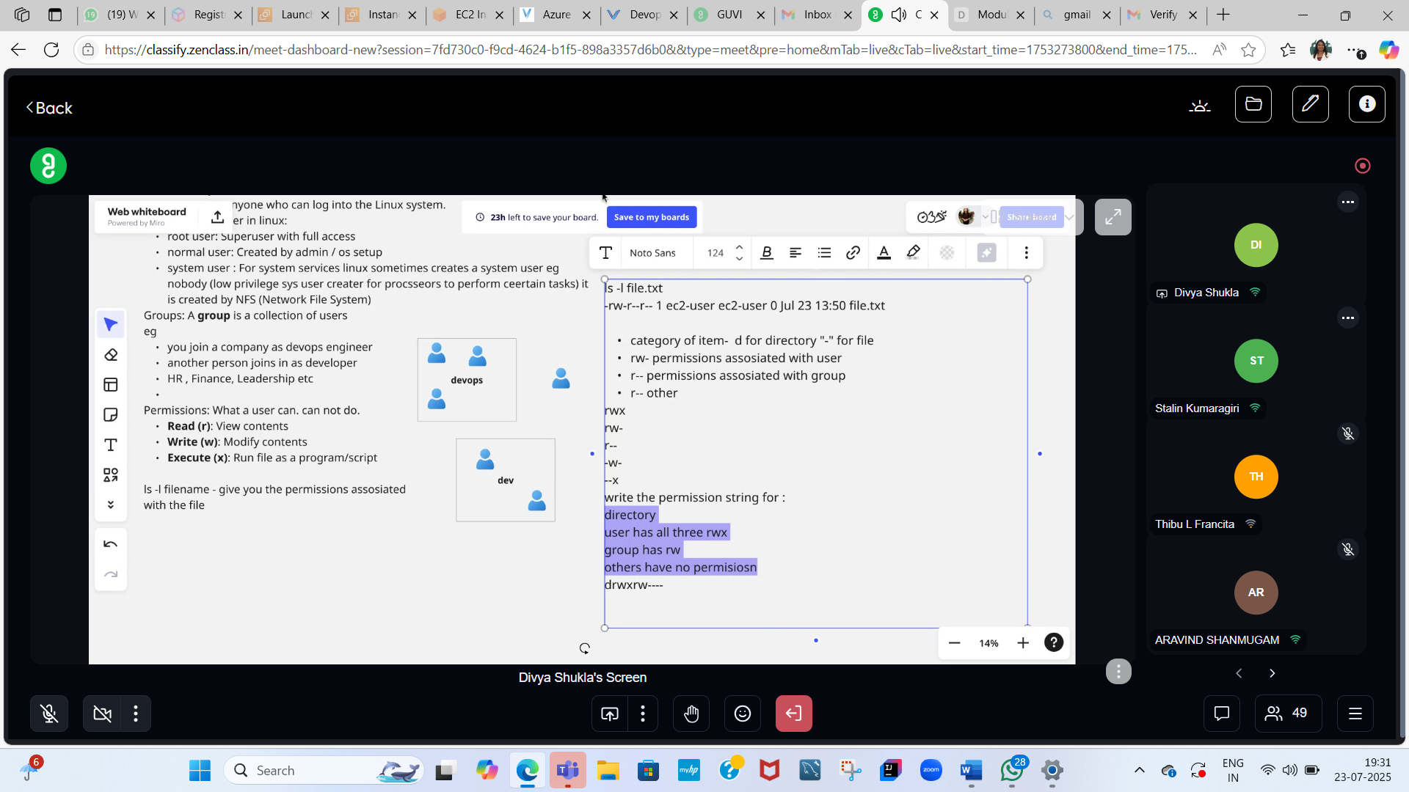

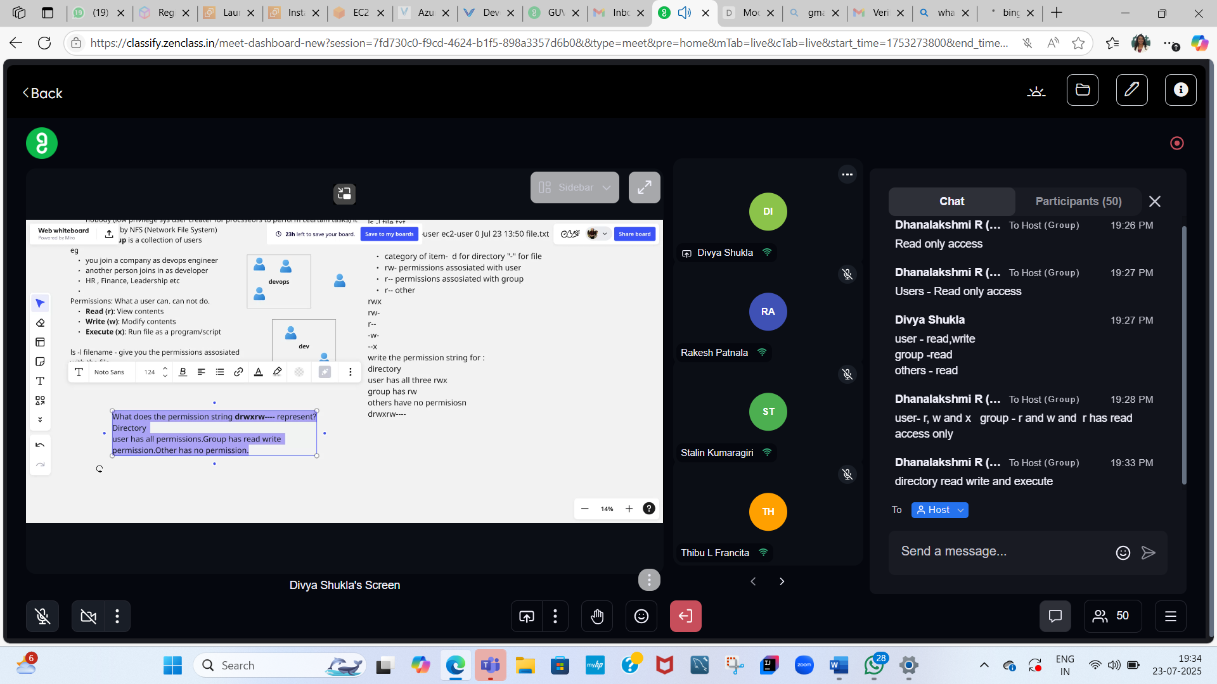

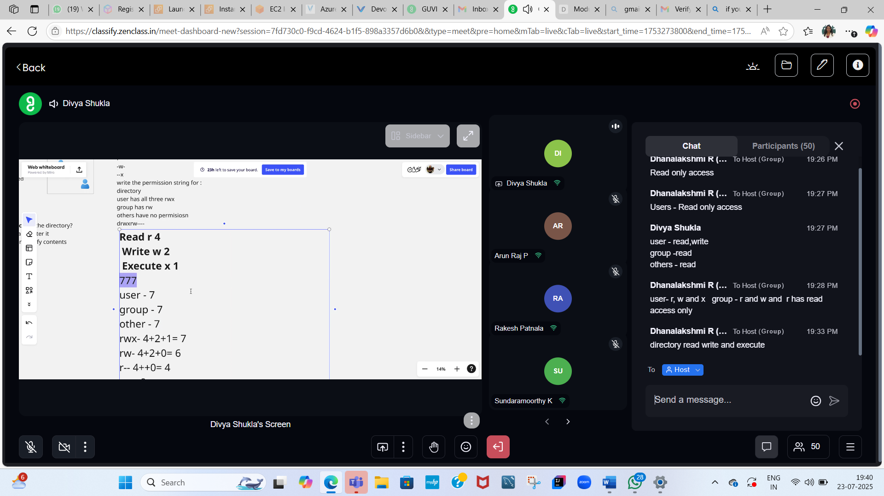

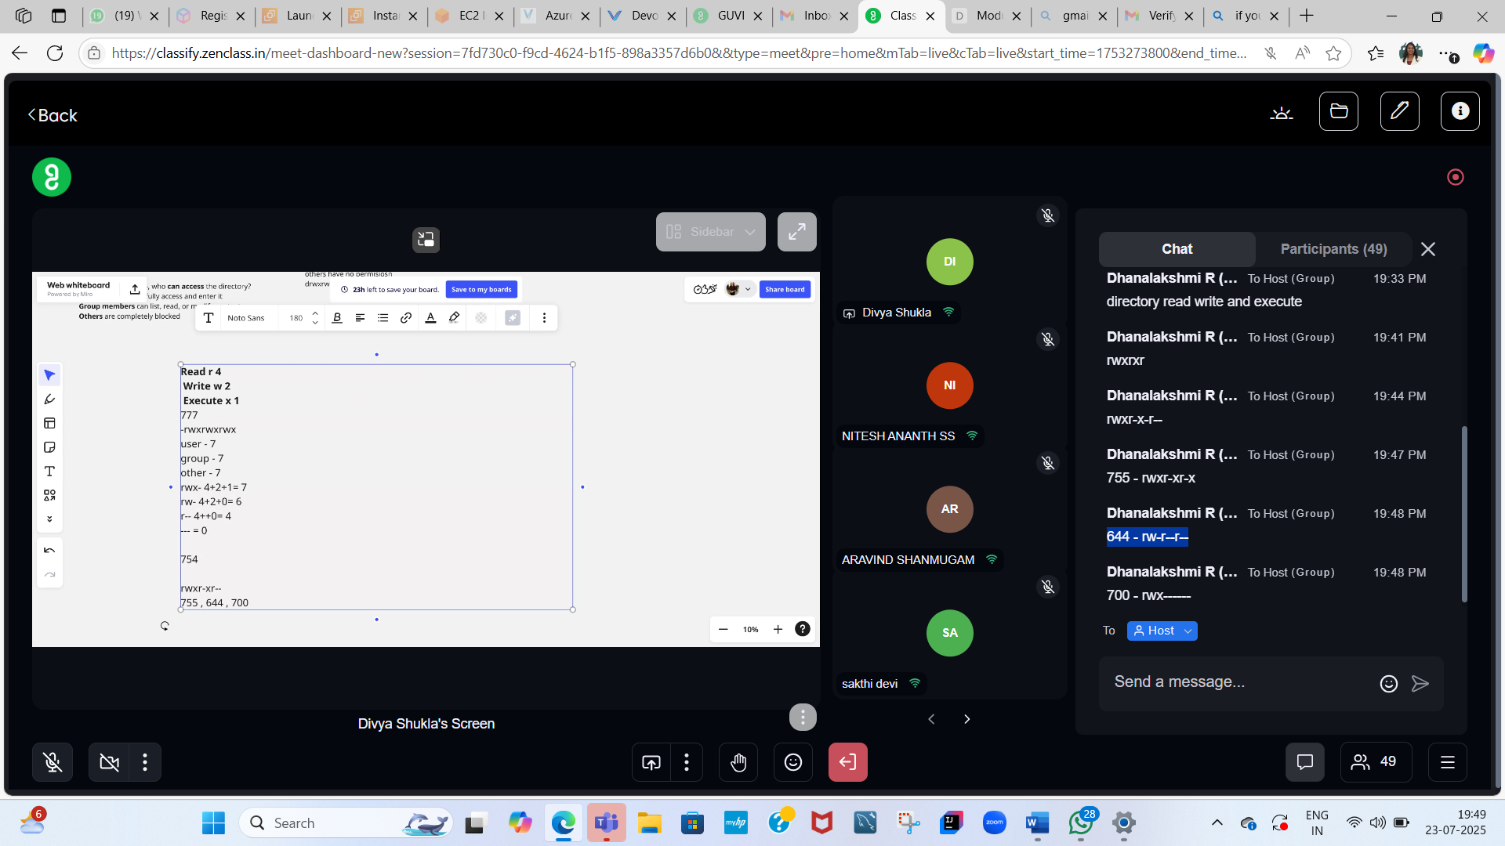

755 - rwxr-xr-x

644 - rw-r--r—

700 - rwx------

07/24/2025

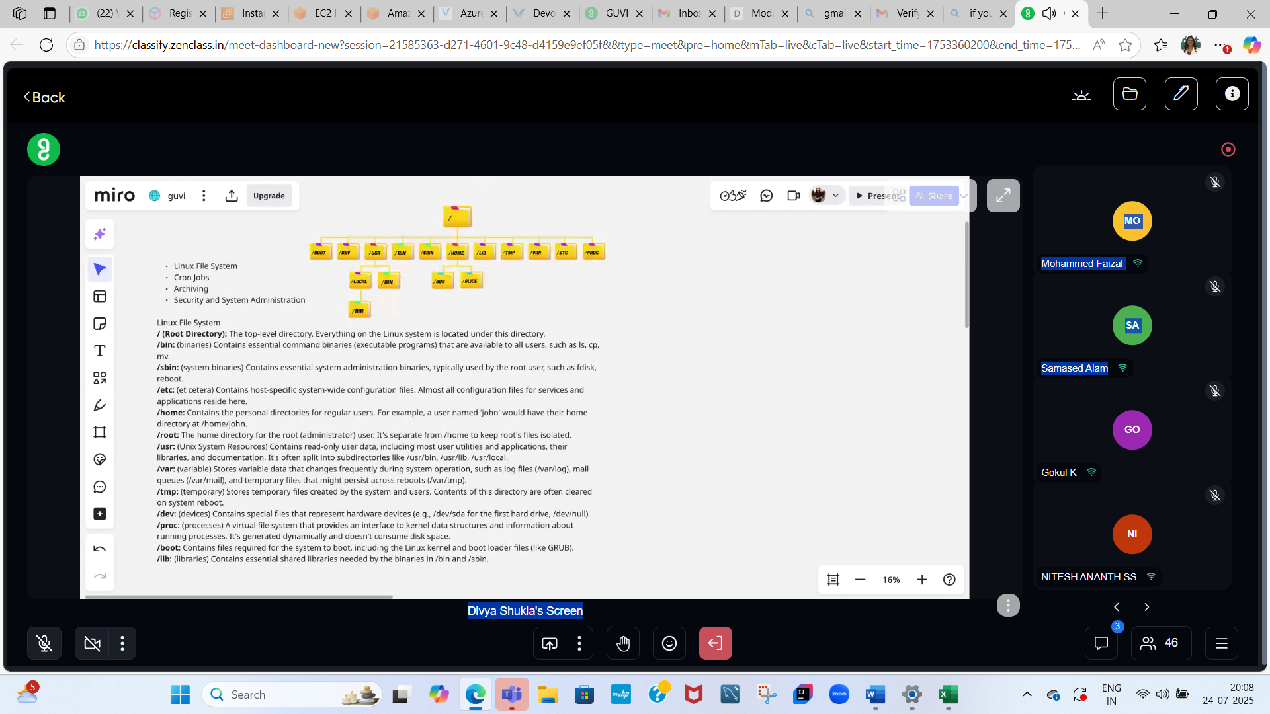

<https://help.ubuntu.com/community/UFW>

I worked in Health and Welfare Non technical domain in Fidelity Investments for 12 years and now I am aspired for Technical roles like Java full Stack Developer, Software Engineer and DevOps engineer or Cloud Engineer roles. I have done Java Full Stack certification from JSPIDERS bangalore. Could you please confirm how can I get into the above mentioned roles and which path should be followed in order to get into the above mentioned tech roles in current market?

I have now registered for the Guvi - DevOps course. It is a course of 3 months which includes - Linux Introduction, NetWork basics, Bash Scripting, AWS, VCS, Build Tools, Docker, Microservices, Kubernetes, SDLC, Jenkins, IAC, Ansible, Cloud Formation, Promethius, Grafana Could you please confirm whether can I learn all this completely and get into DevOps job directly after 3 months of this course? And how much will be the package increment if my current package at fidelity is 12.6 LPA?

**✅ 1. DevOps Resume Draft (Career Transition Format)**

Here’s a customized resume you can use and tailor:

**[Your Name]**

📍 Bangalore, India | 📧 your.email@example.com | 📱 +91-XXXXXXXXXX  
💼 LinkedIn: linkedin.com/in/yourname | 🔗 GitHub: github.com/yourusername

**Career Objective**

Certified DevOps Engineer with 12 years of experience in the Health & Welfare domain at Fidelity Investments. Recently completed a comprehensive DevOps certification program covering Linux, AWS, CI/CD, Docker, Kubernetes, Jenkins, and Infrastructure as Code. Passionate about automation, cloud-native tools, and improving software delivery pipelines. Seeking an entry/mid-level DevOps Engineer role to apply my combined domain expertise and modern DevOps skills.

**Technical Skills**

* **DevOps Tools**: Git, GitHub, Jenkins, Maven, Docker, Kubernetes, Ansible, Terraform, Prometheus, Grafana
* **Cloud**: AWS (EC2, S3, IAM, RDS, CloudFormation)
* **Scripting**: Bash, Shell
* **CI/CD**: Jenkins pipelines, GitHub Actions
* **OS**: Linux (Ubuntu, CentOS)
* **Monitoring**: Prometheus, Grafana
* **Build/Deploy**: Maven, Docker, Helm (basic)
* **IAC**: Ansible, CloudFormation
* **Others**: Agile, SDLC, Postman

**Projects**

**1. CI/CD Pipeline with Jenkins and Docker on AWS**

* Set up Jenkins on EC2 and created end-to-end CI/CD pipelines for a Java-based web app.
* Integrated GitHub repo, Maven build, Docker image creation, and deployed to EC2 via Docker Compose.

**2. Kubernetes Deployment of Microservices**

* Deployed microservices architecture on Minikube and EKS using YAML files.
* Configured Kubernetes Services, Deployments, and Ingress.
* Implemented Horizontal Pod Autoscaling and monitored using Prometheus + Grafana.

**3. Automated Infrastructure with Ansible and CloudFormation**

* Automated provisioning of EC2 instances and software stack using Ansible playbooks.
* Used CloudFormation to spin up VPC, EC2, RDS for test environments.

**Certifications**

* **DevOps Engineer Certification – Guvi (In Progress)**
* **Java Full Stack Developer – JSPIDERS Bangalore**

**Professional Experience**

**Fidelity Investments – Bangalore, India**  
*Senior Associate – Health & Welfare Domain (2011 – 2023)*

* Worked with cross-functional teams supporting financial and benefits platforms.
* Gained exposure to release cycles, support processes, and compliance workflows.
* Collaborated with technical teams, giving a strong foundation in business-tech coordination.

**Education**

**Bachelor of Commerce**, [University Name], [Year]

**✅ 2. DevOps Project Ideas for GitHub Portfolio**

**🌐 Project 1: CI/CD Pipeline for Java App on AWS**

**Stack**: GitHub → Jenkins → Maven → Docker → EC2

* Create a Spring Boot app and push to GitHub
* Set up Jenkins on AWS EC2
* Automate build → Dockerize → Deploy on another EC2

**☁️ Project 2: Kubernetes Deployment of a Multi-C**

**☁️ Project 2: Kubernetes Deployment of a Multi-Container App**

**Stack**: Docker + K8s + Helm + Prometheus + Grafana

* Sample microservice (e.g., user + product services)
* Build Docker images and deploy on Minikube or AWS EKS
* Set up Prometheus & Grafana for monitoring

**⚙️ Project 3: Infrastructure as Code for AWS using CloudFormation**

**Stack**: CloudFormation + EC2 + S3 + RDS

* Automate infrastructure setup
* Include Ansible for post-provisioning config (like installing Java or Nginx)
* **✅ 3. 3-Month DevOps Study Plan**

| **Week** | **Focus Area** |
| --- | --- |
| Week 1–2 | Linux basics, Shell Scripting, Networking concepts |
| Week 3–4 | Git, GitHub, Maven, Jenkins (hands-on pipelines) |
| Week 5–6 | AWS (EC2, S3, IAM), CI/CD pipeline project |
| Week 7–8 | Docker, Docker Compose, Kubernetes basics |
| Week 9–10 | Deploy app on K8s, monitoring with Prometheus & Grafana |
| Week 11–12 | IAC (Ansible, CloudFormation), Resume/GitHub polish, Job search start |

Would you like me to:

* Format the above resume into a downloadable Word or PDF version?
* Help you create GitHub README.md files for your projects?
* Create a LinkedIn post announcing your DevOps transition to attract recruiters?

Let me know — I’ll help you with whichever next step you choose.

Ask ChatGPT

**Task 1: Given on 23/07/2025**

Create a directory called ""my_folder"", navigate into it, and create a file named ""my_file.txt"" with some text. Then, create another file named ""another_file.txt"" with some text. Concatenate the content of ""another_file.txt"" to ""my_file.txt"" and display the updated content. Finally, list all files and directories in the current directory. Create 20 files with .txt extensions and rename the first 5 files to .yml extension and Print the latest created top 5 files among the total no of files"

# Step 1: Create a directory named "my_folder"

mkdir my_folder

# Step 2: Navigate into "my_folder"

cd my_folder

# Step 3: Create "my_file.txt" with some text

echo "This is the content of my_file.txt" > my_file.txt

# Step 4: Create "another_file.txt" with some text

echo "This is the content of another_file.txt" > another_file.txt

# Step 5: Concatenate content of "another_file.txt" to "my_file.txt"

cat another_file.txt >> my_file.txt

# Step 6: Display the updated content of "my_file.txt"

cat my_file.txt

# Step 7: List all files and directories in the current directory

ls -l

# Step 8: Create 20 .txt files (file1.txt to file20.txt)

for i in {1..20}; do echo "Sample text $i" > file$i.txt; done

# Step 9: Rename the first 5 files to have a .yml extension

for i in {1..5}; do mv file$i.txt file$i.yml; done

# Step 10: Print the latest created top 5 files among all

ls -lt | head -n 5

**Explanation:**

* mkdir, cd, echo, cat, ls are basic Unix/Linux commands.
* >> appends content.
* for loops are used to automate file creation and renaming.
* ls -lt lists files by **modification time**, newest first.

25/07/2025

SSH Instance creation and SCP (Secure Copy Protocol)

SSH is securely connecting from one machine to another

SCP is securely transfer the files from local machine to remote computer

*To launch SSH – instance on AWS

-Launch Ubuntu Instance and create Keypair – RSA – keep other things as it is and create

-It will create a .pem file -> Download and save it on desktop or any

-On .pem file open git bash or on .pem file – Right clieck and open Terminal

-Copy and paste the SSH command from SSH client –

ssh -i "test.pem" [ubuntu@ec2-3-23-104-112.us-east-2.compute.amazonaws.com](mailto:ubuntu@ec2-3-23-104-112.us-east-2.compute.amazonaws.com)

-click enter

-then type pwd

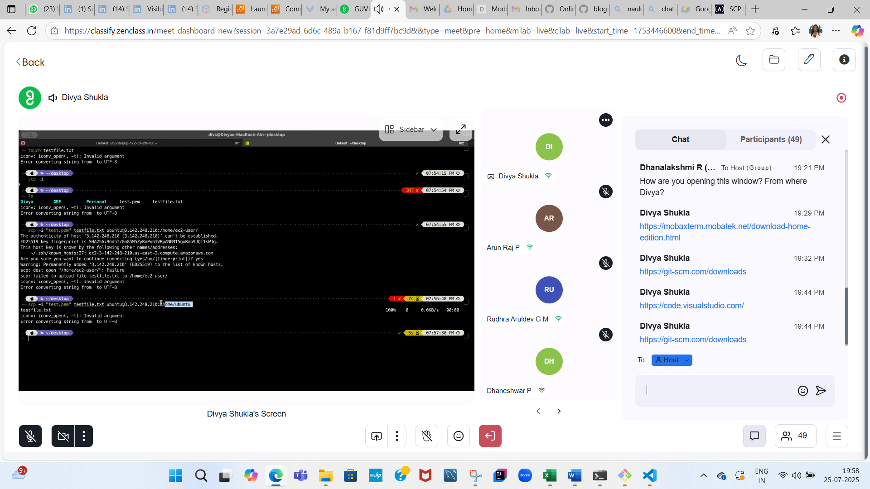

Refer



[SCP Linux Command – How to SSH File Transfer from Remote to Local](https://www.freecodecamp.org/news/scp-linux-command-example-how-to-ssh-file-transfer-from-remote-to-local/)

**SCP Linux Command – How to SSH File Transfer from Remote to Local**

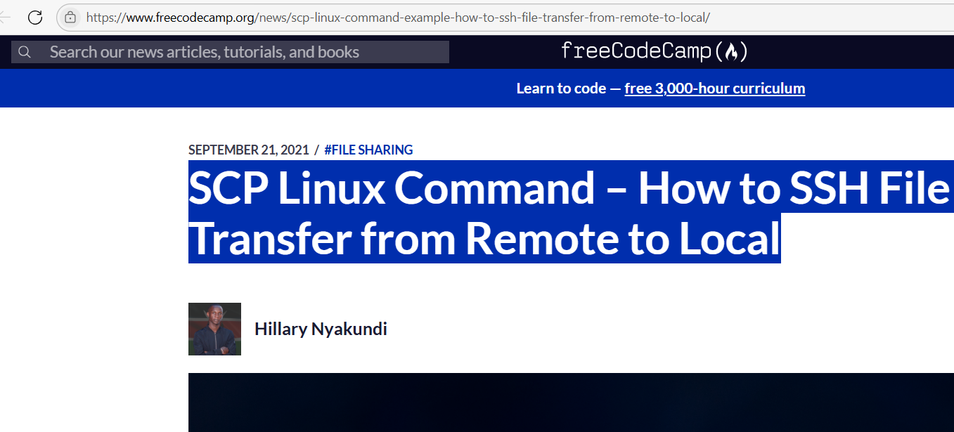

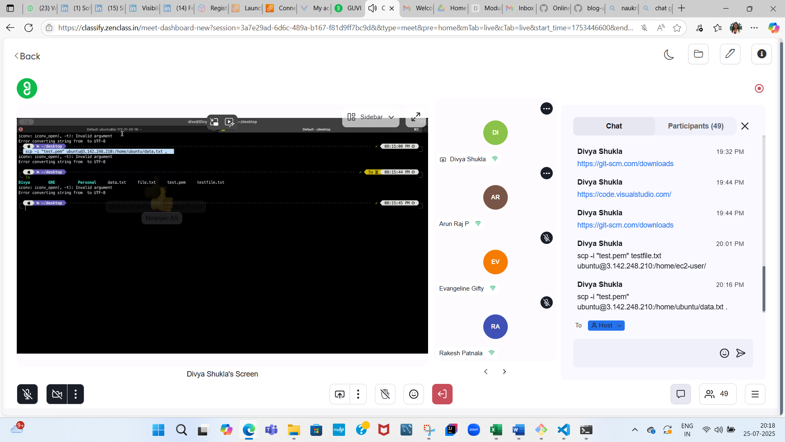

**OSI ---- Very Important from Interview stand point**

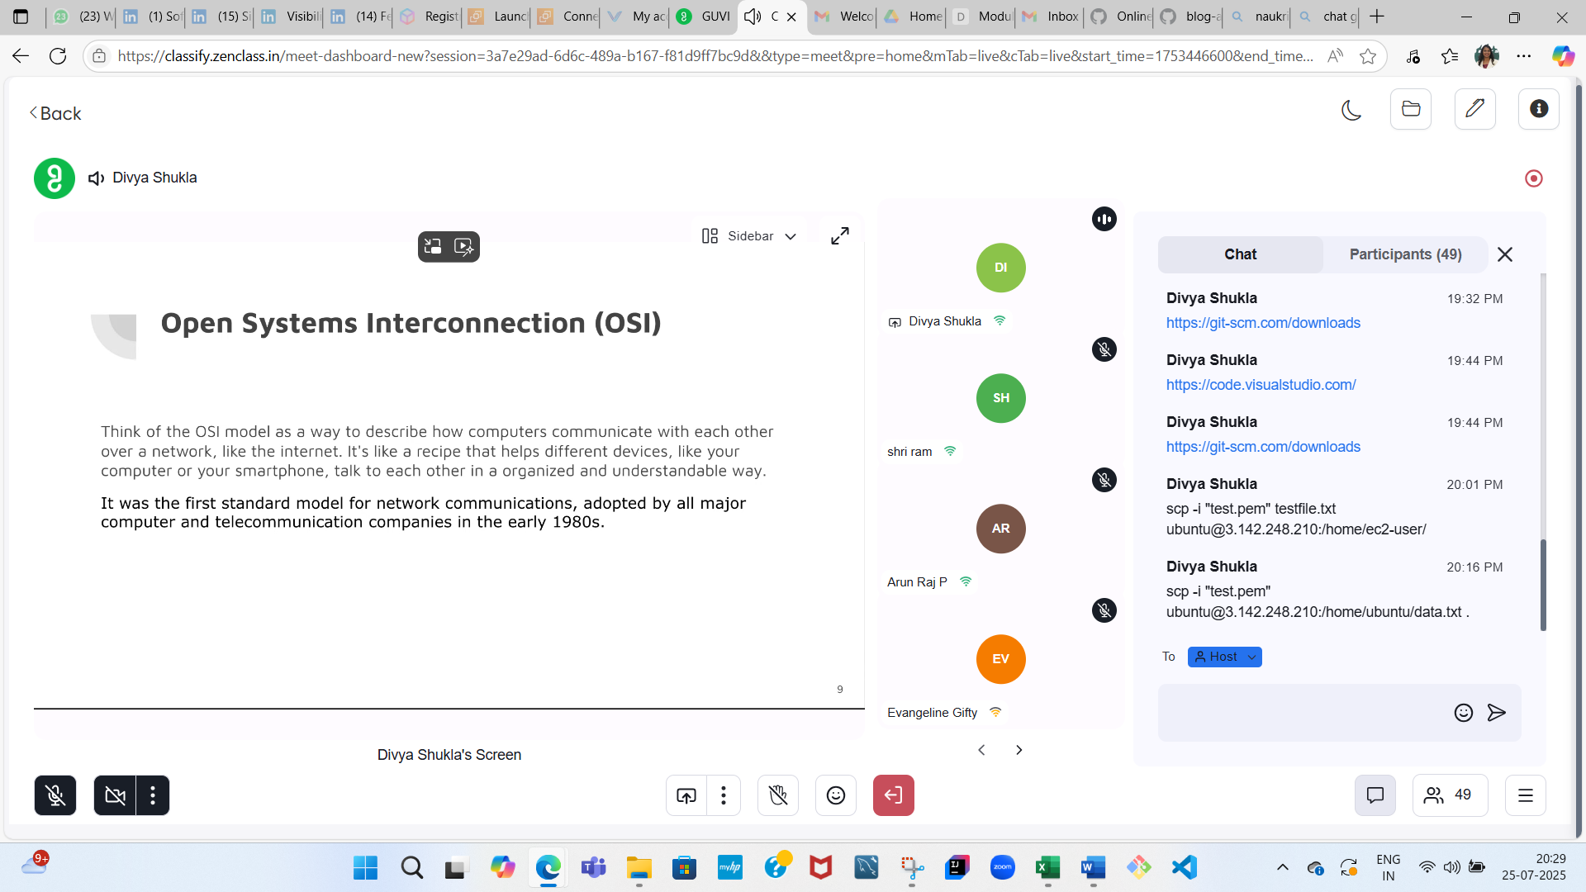

There are 7 OSI layers:

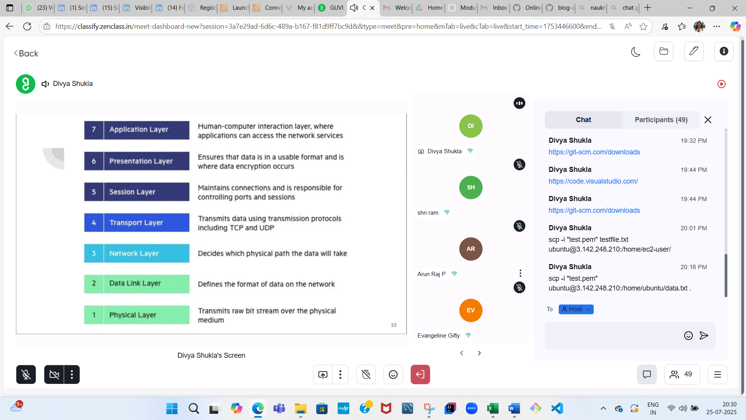

<https://www.cloudflare.com/learning/ddos/glossary/open-systems-interconnection-model-osi/> - Pre Read for Monday – 07/28/2025 given on 07/25

Important for Interview

<https://medium.com/@abhirup.acharya009/understanding-tcp-and-udp-building-blocks-of-connectivity-ec96e208b852>

29/07/2025

OSI – 70-80% Interview questions

**And there are 7 layers:**

1.**Physical layer**

2. **Dada Link layer** – Remember MAC address concept

- It’s the layer which is responsible for node to node data transfer. 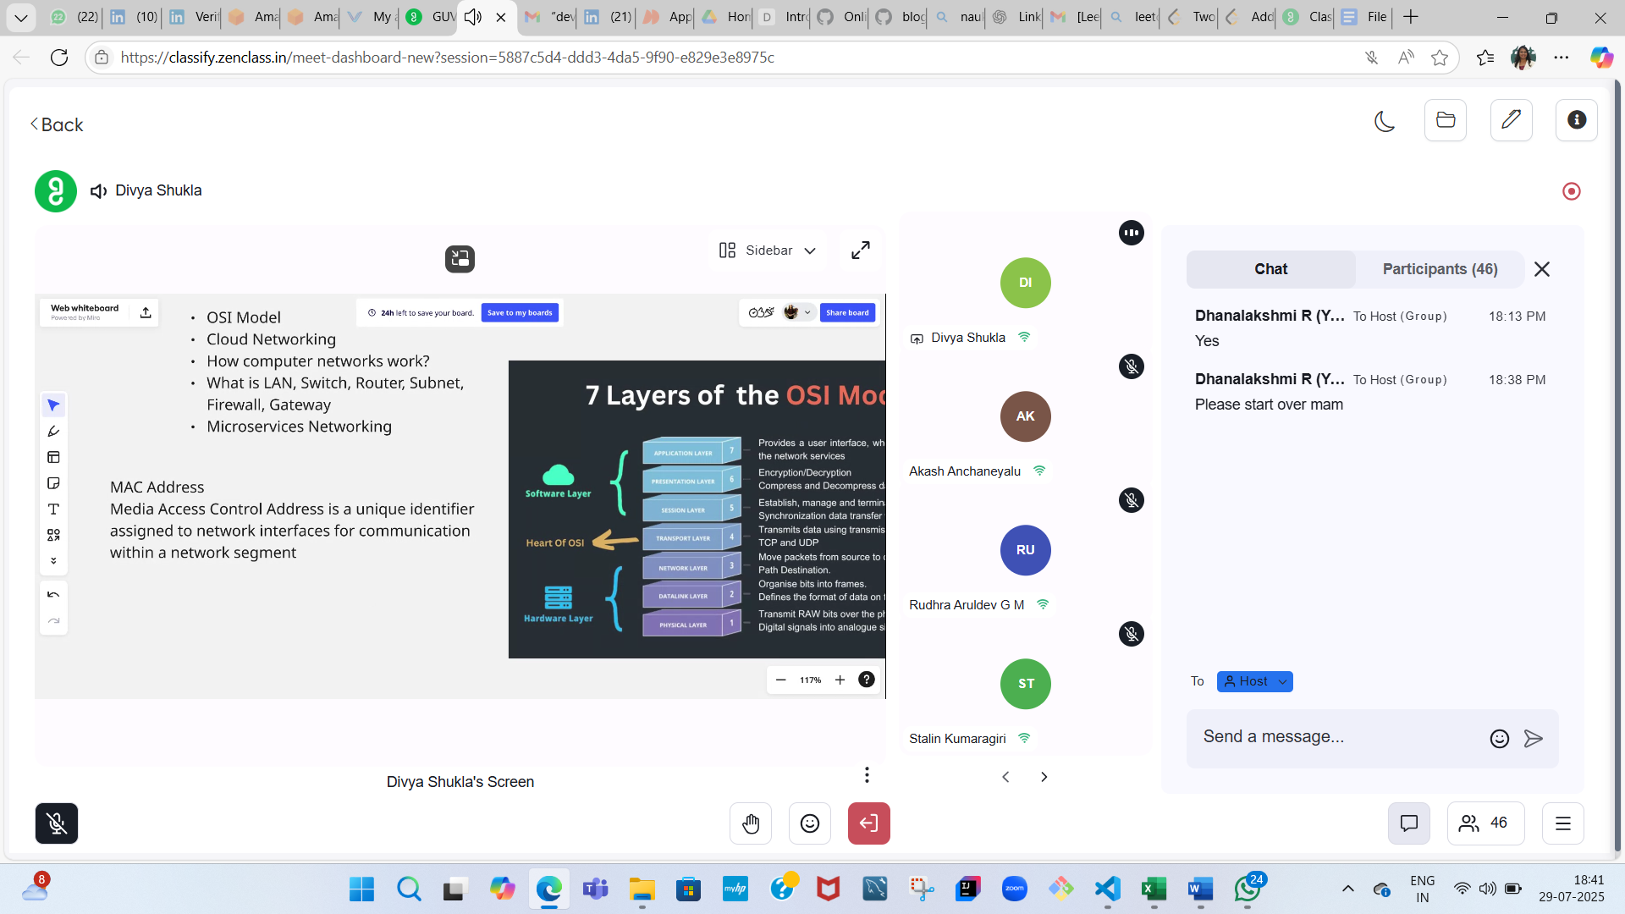

**3. Network Layer** – Internet Protocol

**4.Transport Layer** (V. Important) – It will ensure that the data transfer occurs between 2 systems

There are 2 important transmition protocols called – TCP and UDP

**TCP** – Transmission Control Protocol :-

It is a connection oriented protocol. Data Packets – It’s nothing but chunks

It will assign the data into chunks

**It is highly reliable protocol.**

**TCP Handshake:**

**1 step is – Synchronise**

**2nd step – Synchronise and acknowledge**

**3rd step - And acknowledge**

**Learn about FTP and SFTP**

**TCP is the underlined transport for HTTP and HTTPS connection. – As it is more reliable**

**UDP** – User Datagram Protocol :-

They both

**5. Session Layer -** Connection establishment time limit (Period of time that is dedicated for a particular login when not in use)

**6.Presentation Layer** – It converts the data into other users understandable format

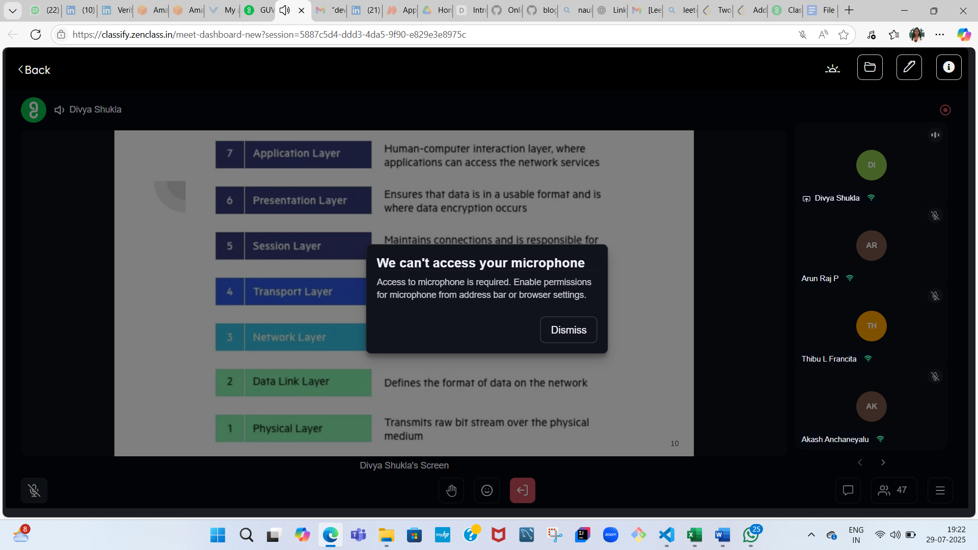

7. Application Layer:

Learn about Monolithic and Microservice Architecture.

Monolithic – Entire code base will be in one system.

Migrating Monolithic architecture to Microservice architecture.

Microservice Architecture: Synchronous Architecture and Asynchronous

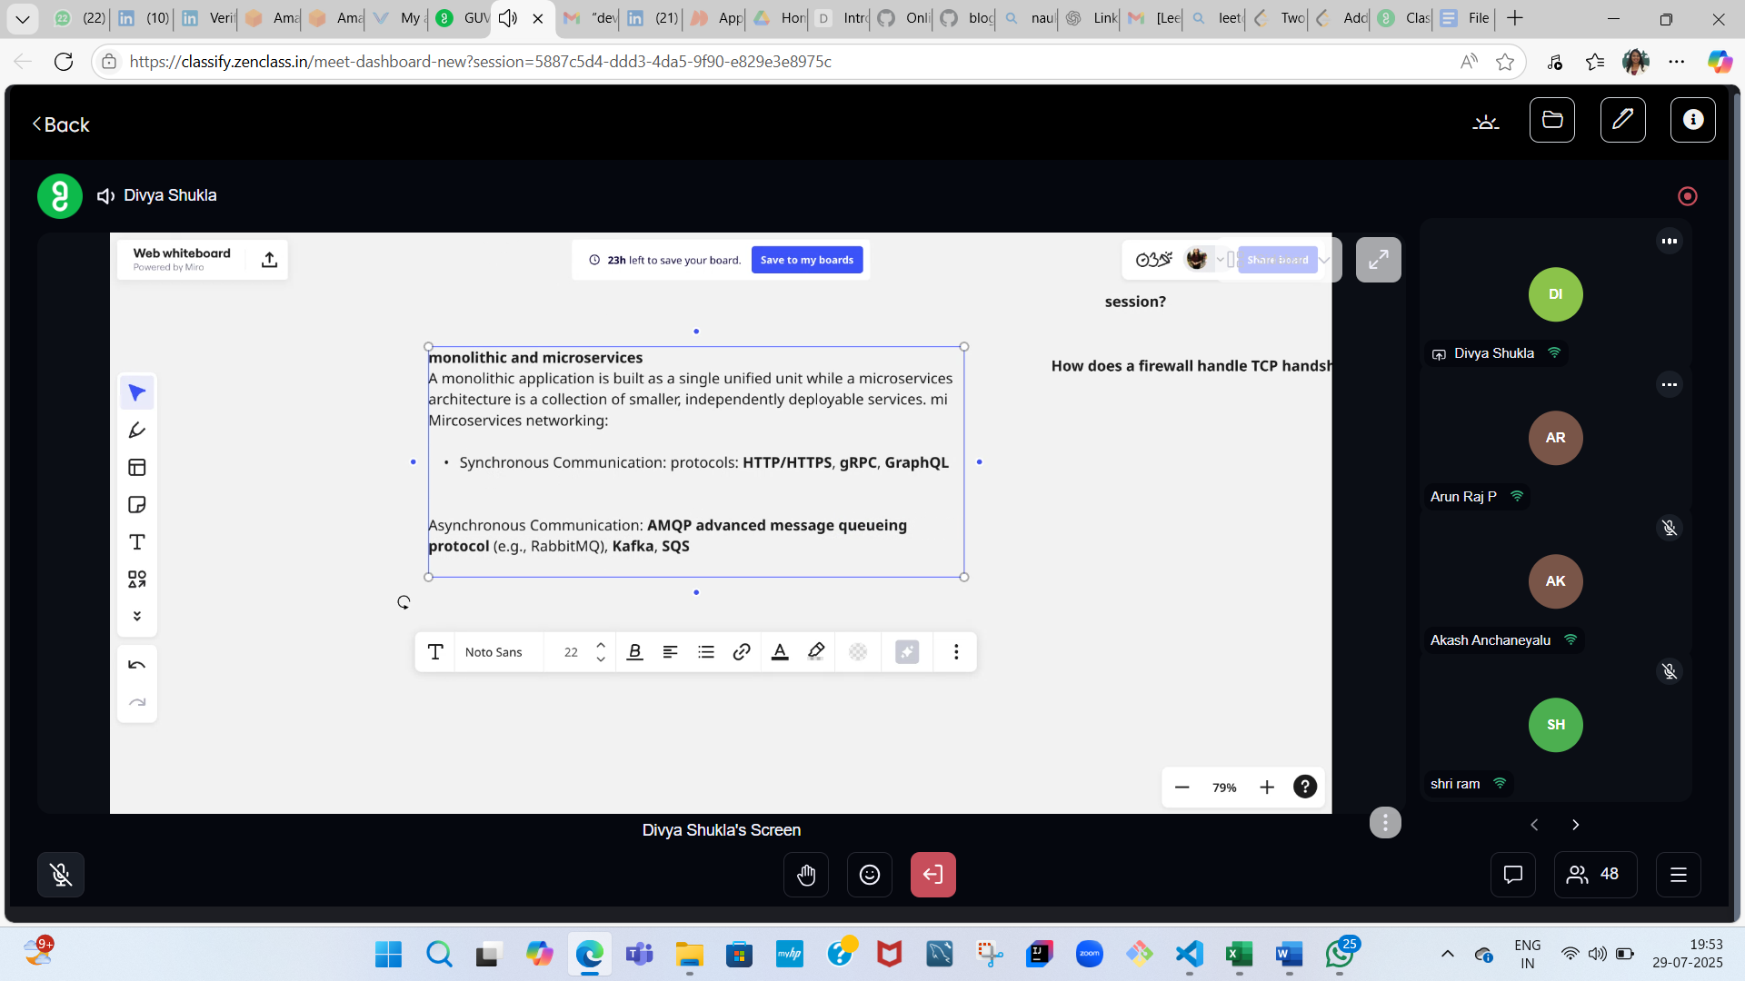

Cloud Networking – Core concepts of Cloud Networking is – VCP, Private Network

Divya Shukla: FTP (File Transfer Protocol) and SFTP (Secure File Transfer Protocol). ; SSL / TLS Collapse

ssl/tls

FTP (File Transfer Protocol) and SFTP (Secure File Transfer Protocol). ; SSL / TLS

<https://docs.oracle.com/en-us/iaas/Content/Network/Tasks/Overview_of_VCNs_and_Subnets.htm>

<https://cloud.ibm.com/docs/vpc?topic=vpc-getting-started>